Earn Your High School Diploma
Calling All High School Age Students
Have you given up on That High School Diploma?
Earn your diploma by choosing one of these options today!
SLPS Virtual Academy SLPS Fresh Start
REQUIREMENTS
- Placement Test * Placement Test
- 3 Hours a Day * 3 Hours a day
- Computer base learning * Books provided
- NO uniforms * NO uniforms
- Under age 21 years old * 17-21 years old
- 13 Units of credits * 0 or more credits
INCENTIVES: INCENTIVES:
- Catch up on core classes * Comprehensive school program
- Math, English, Science, Social Studies * Core Studies
- 15 hours per job or community services * 20 hours per job or community services
- Earn 8 credits a year * Diploma upon successful completion
- Diploma upon successful completion * One locations @ Sumner High School
- 4 locations (Gateway, Roosevelt, Vashon & Sumner)
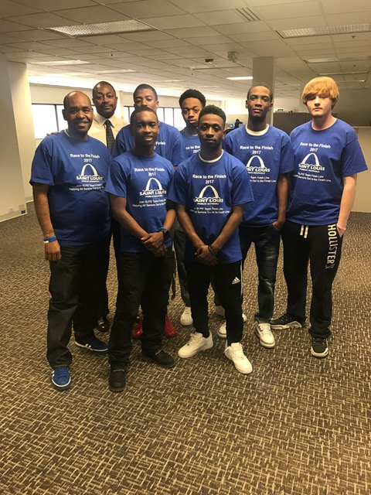
F. Y. I.
You may very well graduate in May
FREE! BUS TICKETS WHILE ATTENDING SCHOOL
Assistance in job search and community services work
Your current job, or community service activities, may already apply towards graduation requirements.
City residents may register today by contacting:
Charlie Bean Carey Cunningham Fresh Start @ Sumner High School
Dropout Recruiter Coordinator Dr. Miranda Avant-Elliott, Principal
(314) 345-4424 (314) 345-2335 (314) 531-2220

